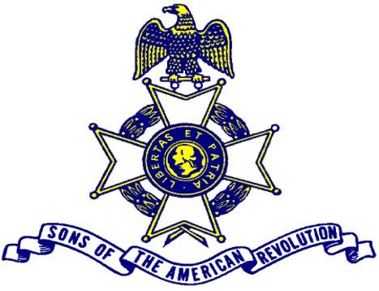

2022 Annual Great Lakes District and ILSSAR Dinner
Reservation Form
Advance reservation required
Dress is Black Tie, Colonial or Business Attire
Dinner Menu
Chicken Breast stuffed with Tomato, Mozzarella and Basil
Served with Cheesy Cheddar Potatoes and Sautéed Vegetables
Berry Field Green Salad
Vanilla cheesecake with chocolate caramel and Heath Bar pieces
Vegetarian option is available
Dinner is in the Vista Rooms on the 29th Floor
6:00 Social Hour
6:45 Presentation of the Colors

Name: ___________________________________________ Number Attending ____________

Guest(s) ____________________________________________________

Society ________________________ Position ___________________

Telephone Number ______________ EMAIL _____________________
Checks Payable to ILSSAR $35 per person for Dinner Vegetarian Option Yes____
Cutoff date for reservations is Oct 10
Return form to Toby Chamberlain
312 Sommerset Drive
Chatham IL 62629
Wyndham City Center Hotel Springfield Illinois
Room Rate is $123.00 plus tax includes two breakfast for each room free covered parking
Wyndham City Center Hotel
https://bit.ly/SAROCT22
217-789-1530
Link to reserve your room

